## Requirements Statement

1. Monday.com API investigation.
2. Monday.com API feasibility analysis

## Iteration Plan

|  |  |
| --- | --- |
| **Goals** | Tasks |
| API document research | Read the API documentation |
| Be familiar with Monday.com's features | Create a Monday.com test account, testing board.  Familiar with Monday.com |
| API authorization & Get token | API authorization & Get token |
| API methods testing | Query, add, delete, update --- boards, groups, items, columns… |

## Monday.com API document study

<https://monday.com/developers/v2#introduction-section>

What I researched:

* What is the Monday.com API?
* How does it work?
* How to get support?

Note: Monday.com API is based on the GraphQL structure**.** (GraphQL – What I can deep research.)

<https://graphql.org/>

## Be familiar with Monday.com's features

What I did:

* Create a test Board
* 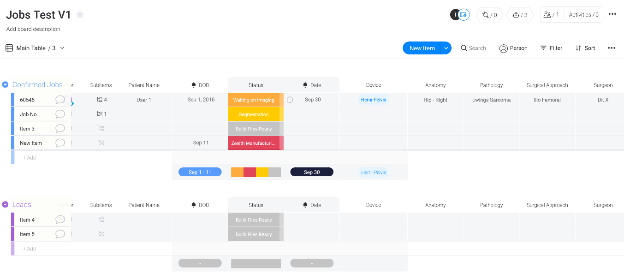Test add, delete, modify, query and other functions.

## API authorization & Get token

What I did:

* Follow the API introduction.
* GET Monday.com account admin permissions.
* Go to the API section, generate a “API V2 Token”.

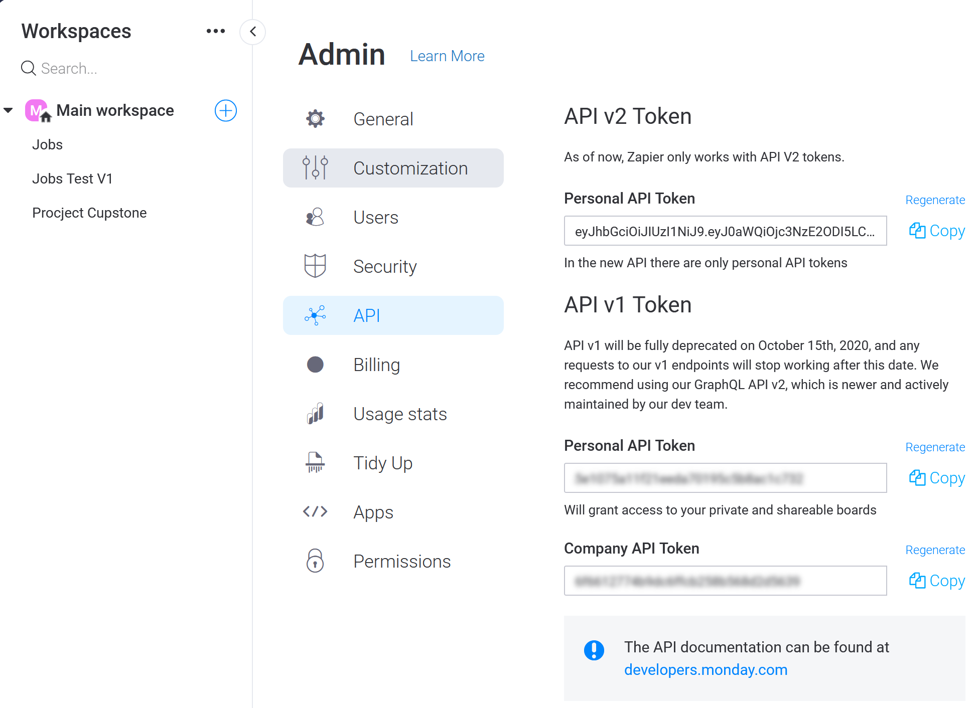

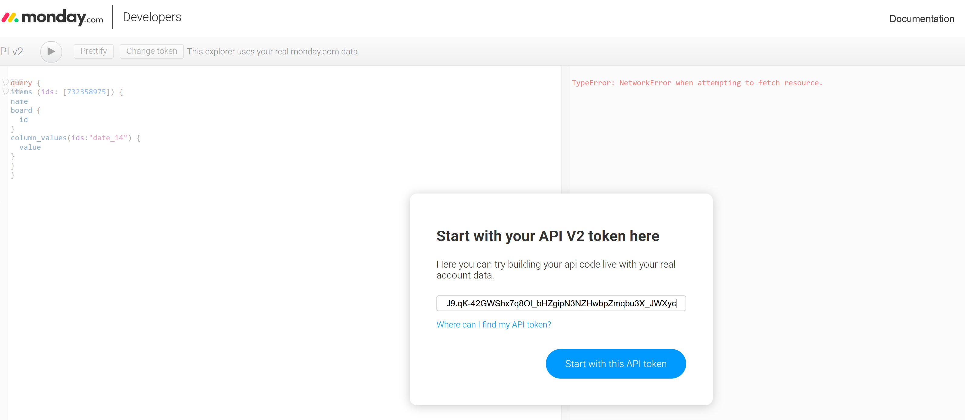

## API methods testing

Querying:

1. Query board:
2. Query group:
3. Query item:
4. Query column:

Q1：What is Monday.com boards?

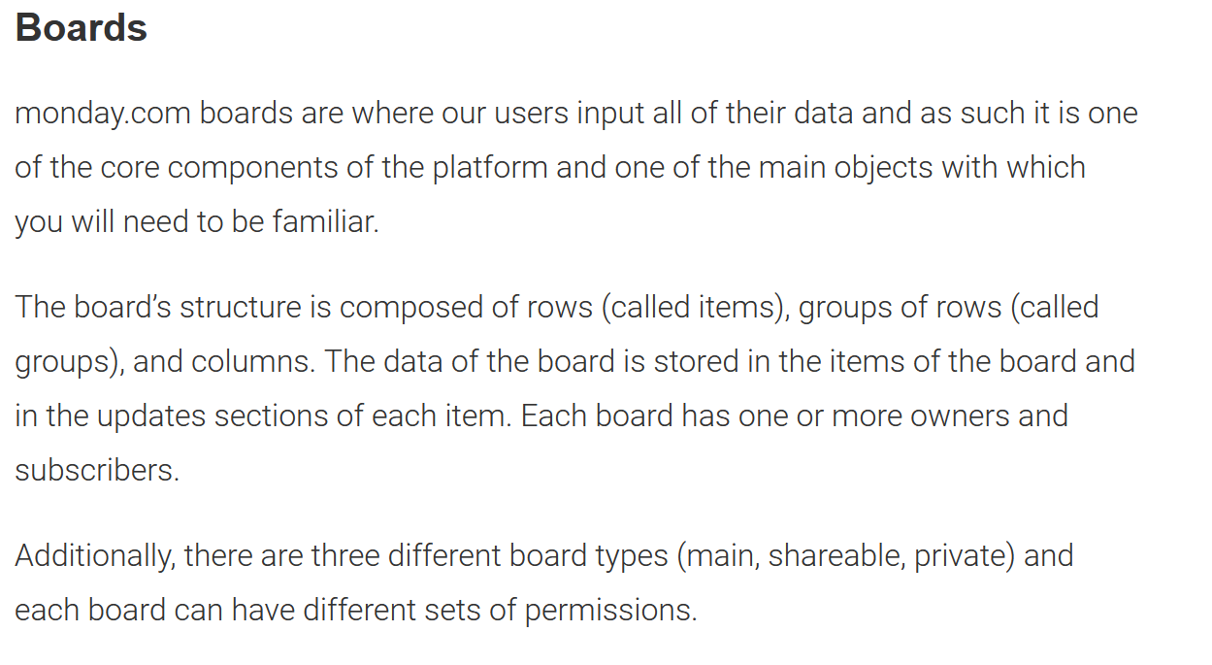

Q2: Where to find board, item, and column IDs

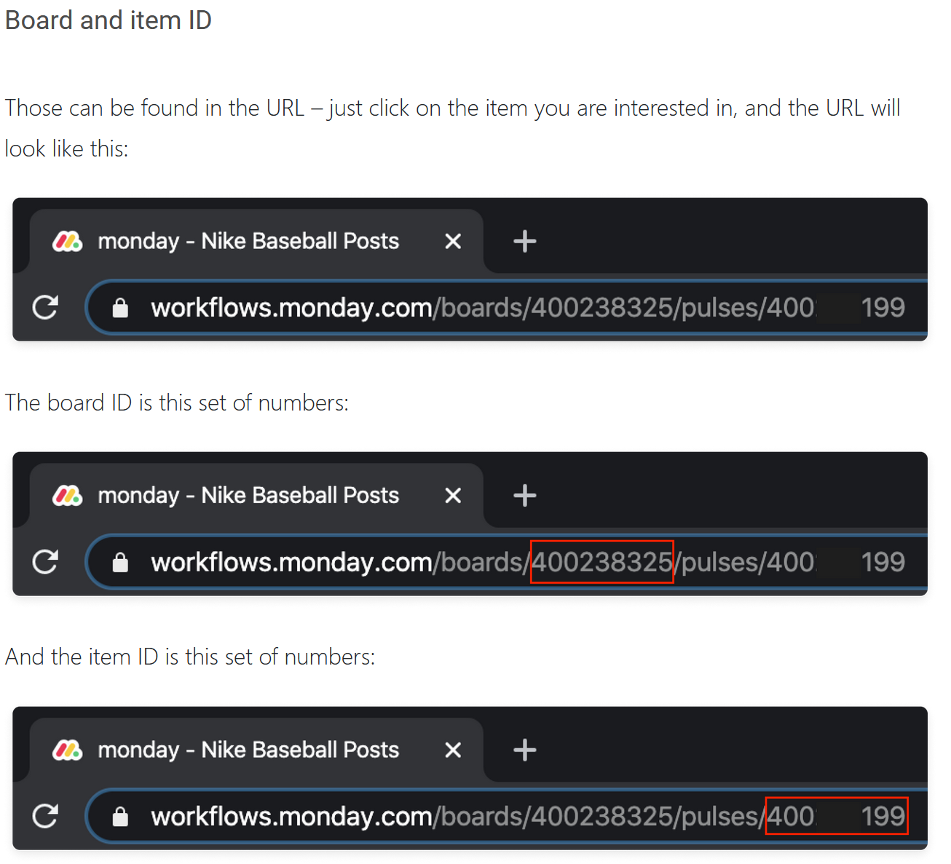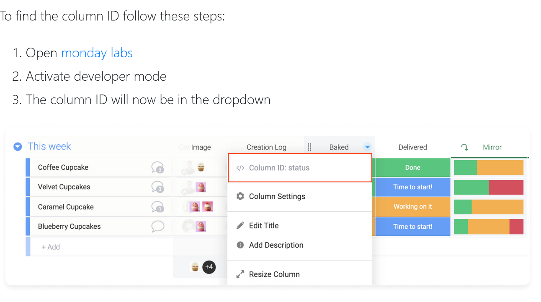

Q3: How to find group ID

Way 1: list group

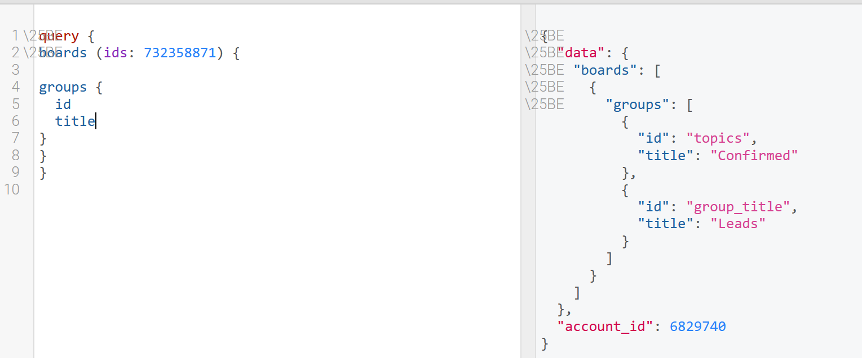

Way 2: use item ID to find the group.

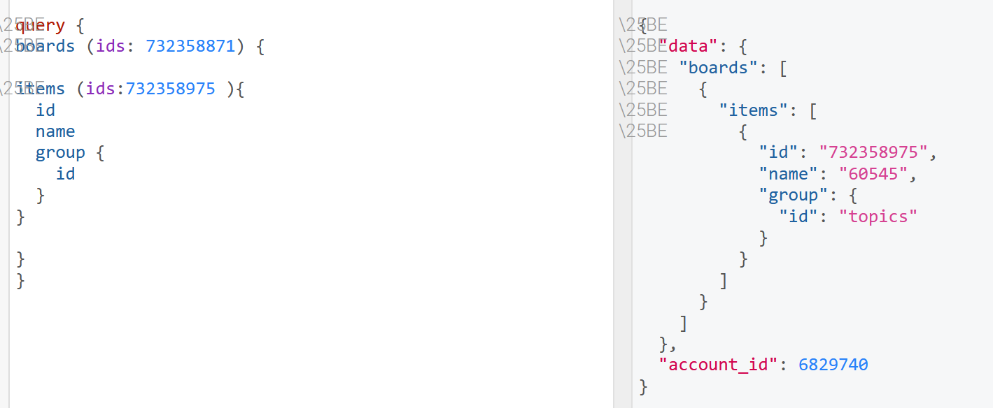

Way 3: When create a group, the group Id will be return. (The same as create a board, item, column…)

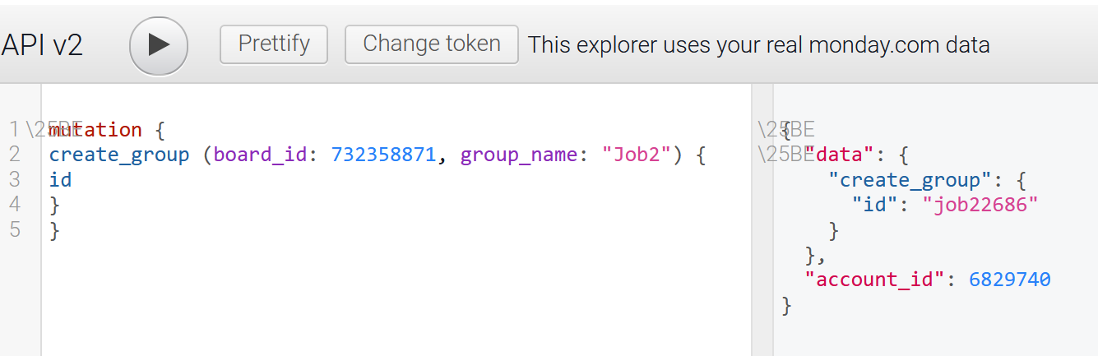

Q4: Get boards views information --- First query

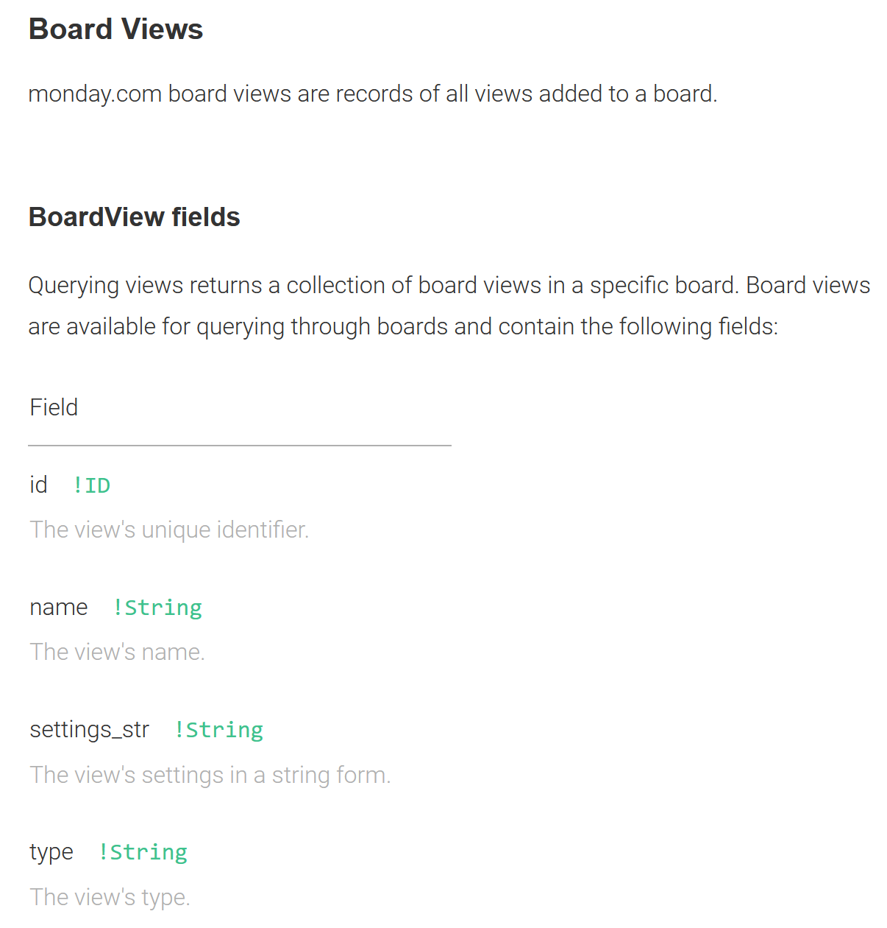 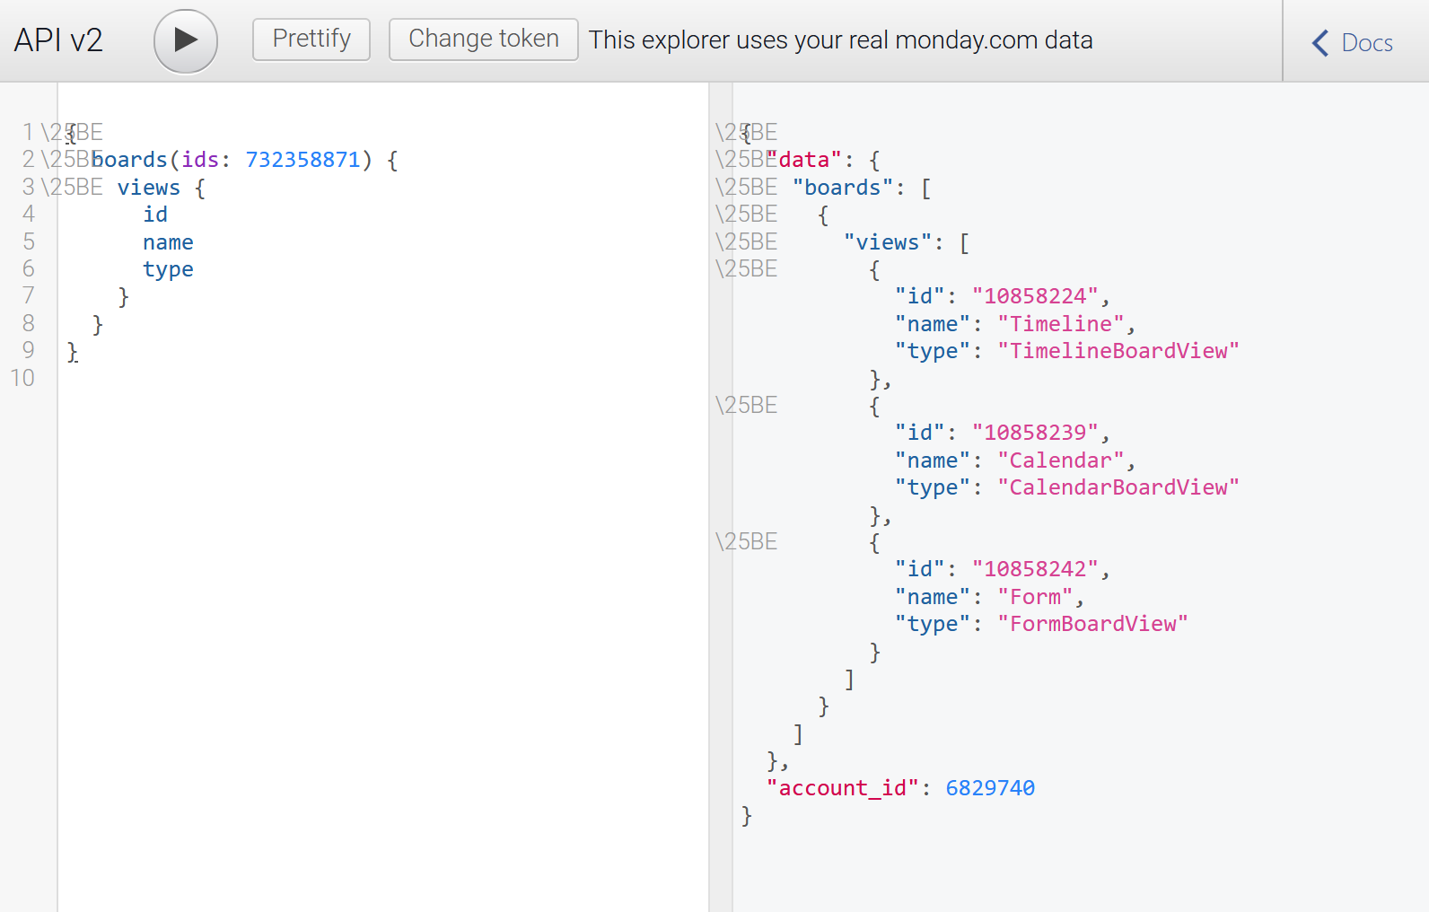

Q5: Querying board with arguments --- Research how to use arguments.

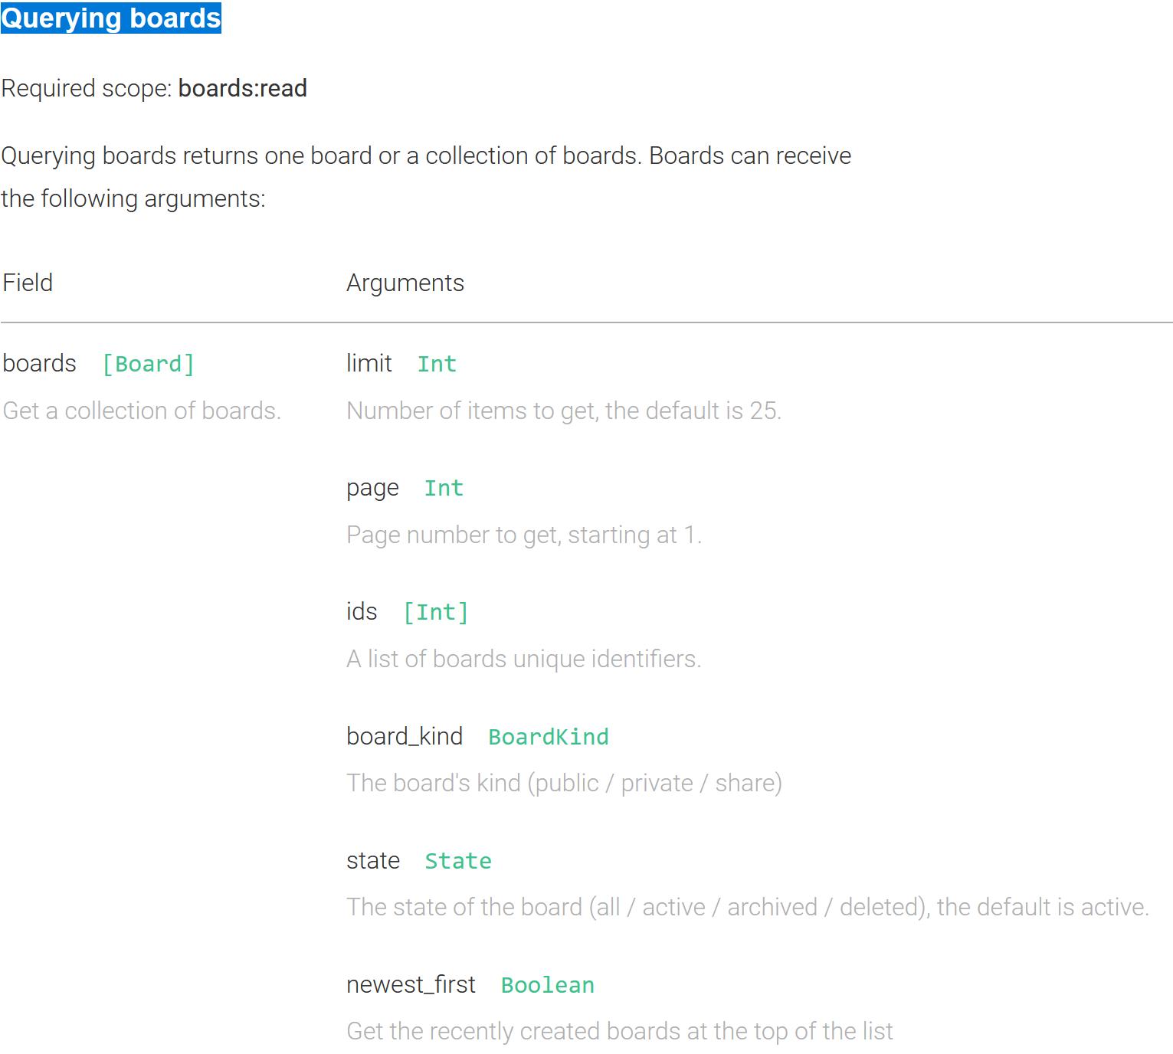 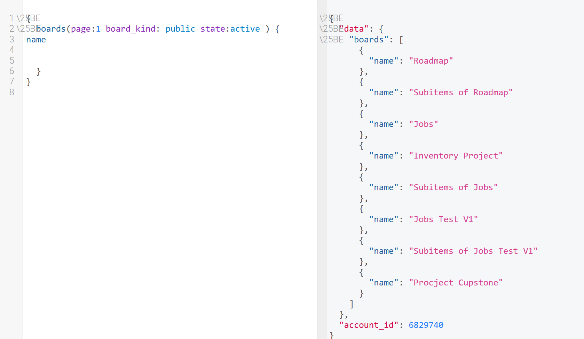

### Q6: Test Board fields: <https://monday.com/developers/v2#queries-section-boards> --- To be Familiar with the fields:

### 

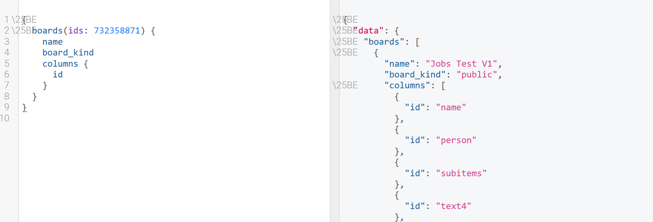

Q7: Groups Method --- Create, Delete, Query, Update

Query:

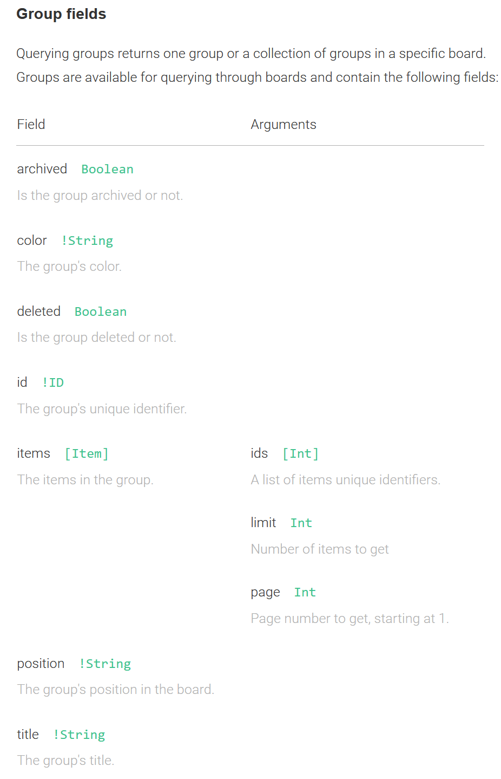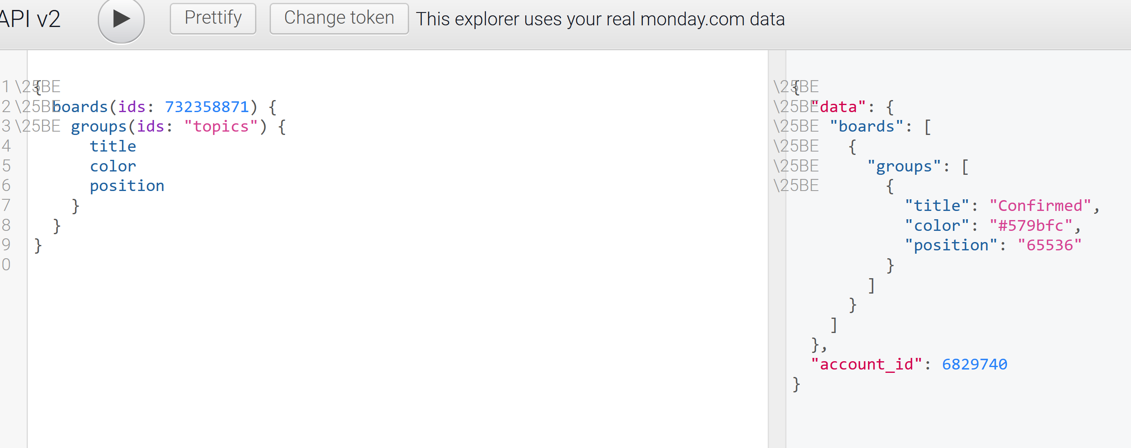

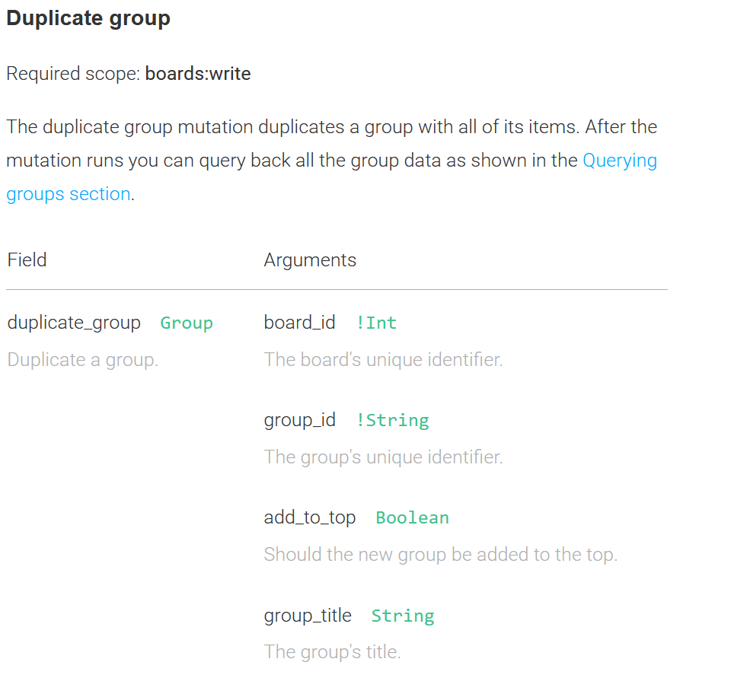 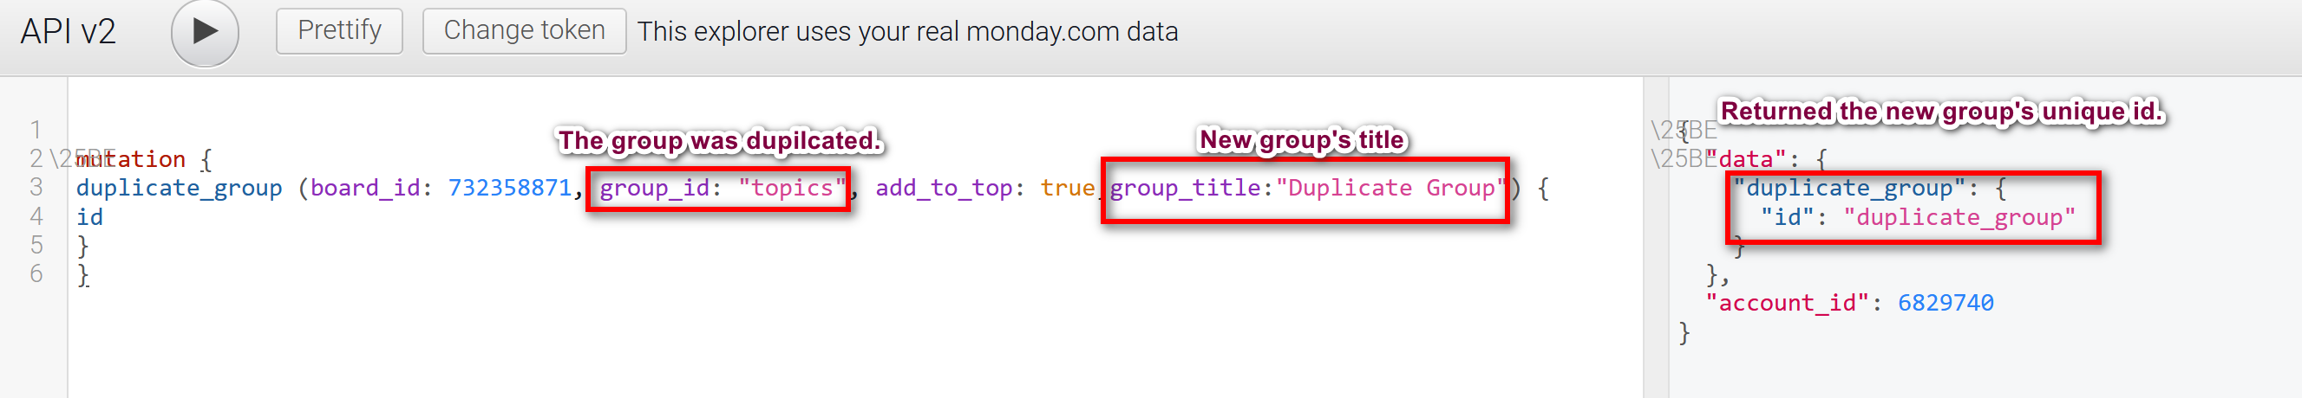

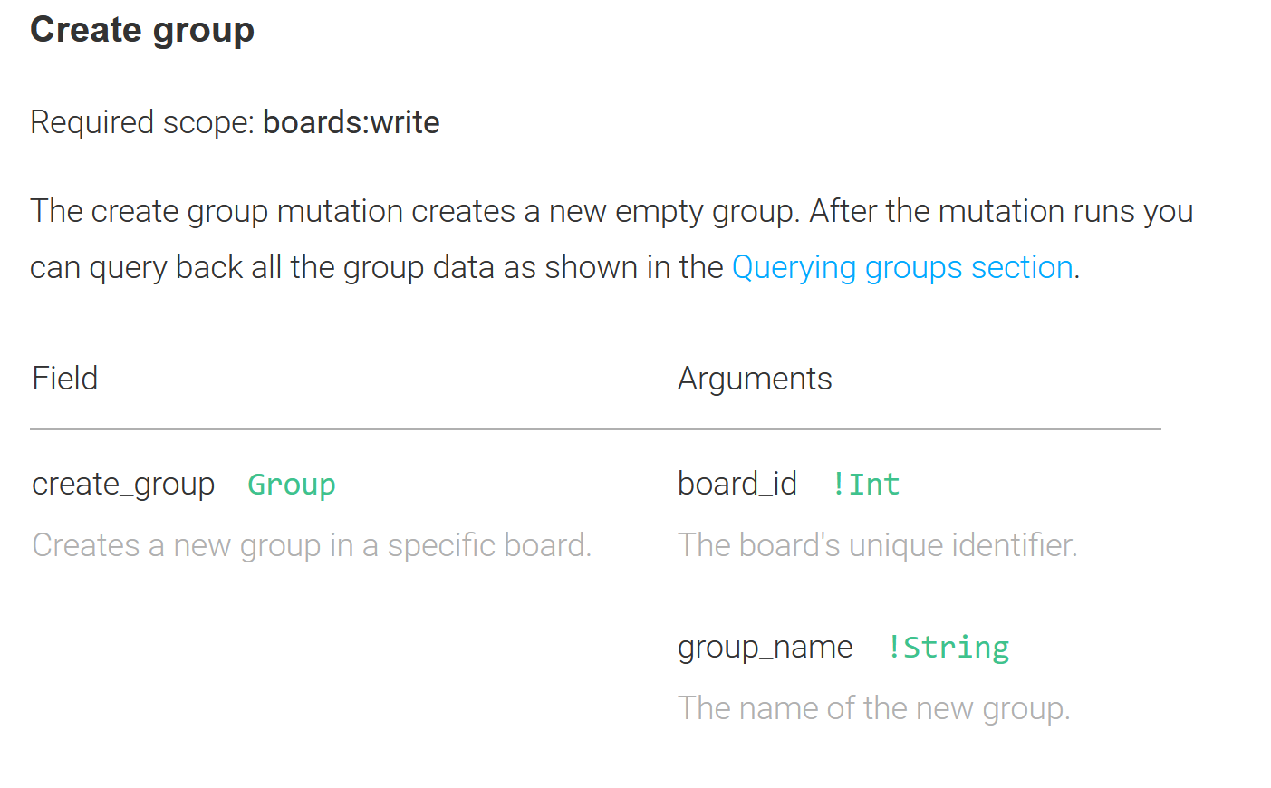 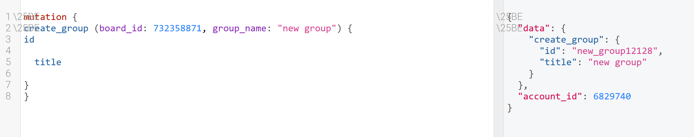

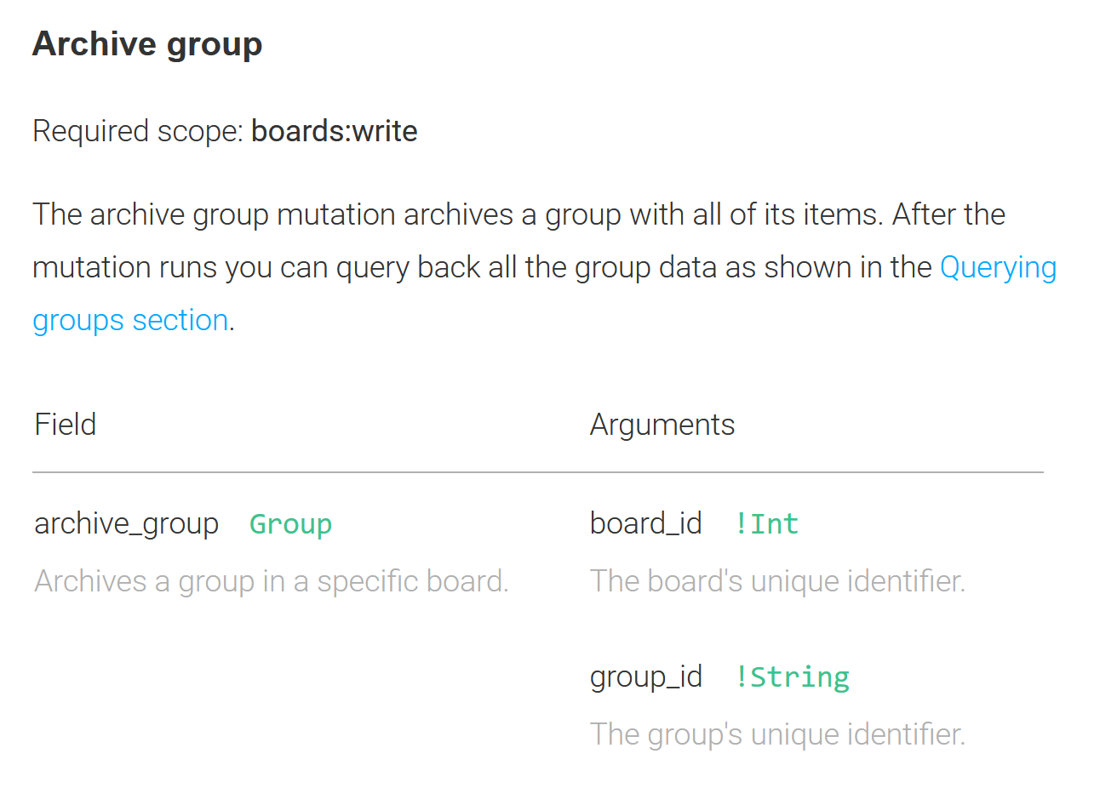 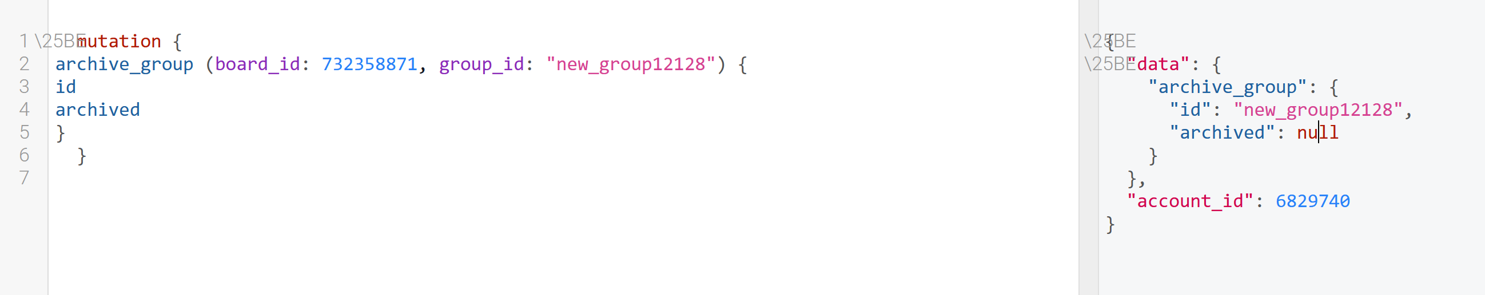

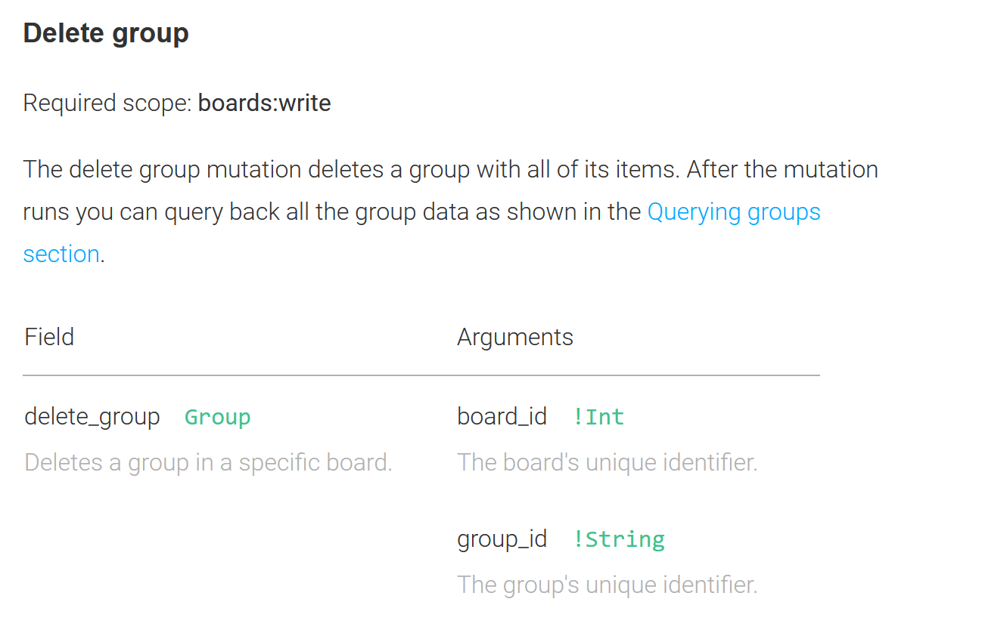 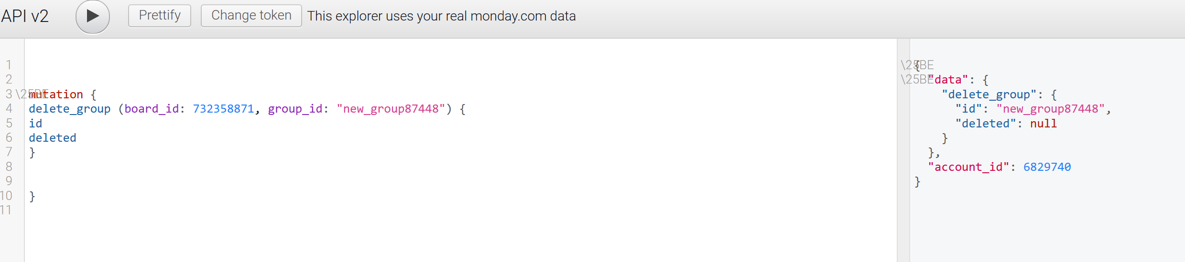

Q8: Create a new testing board though API

Step 1: Create a new board, returned board id.

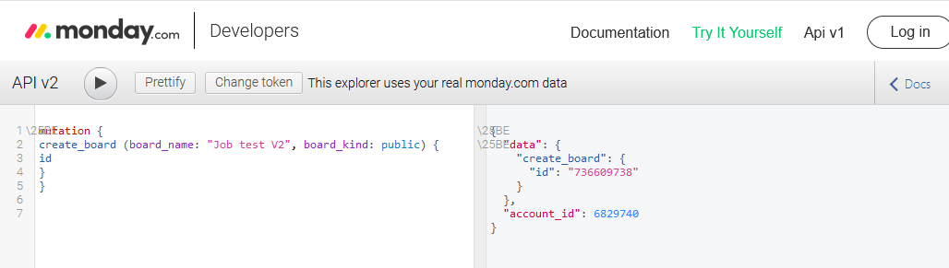

Step 2: Create a new group, called “Confirmed Jobs”. Get group id.

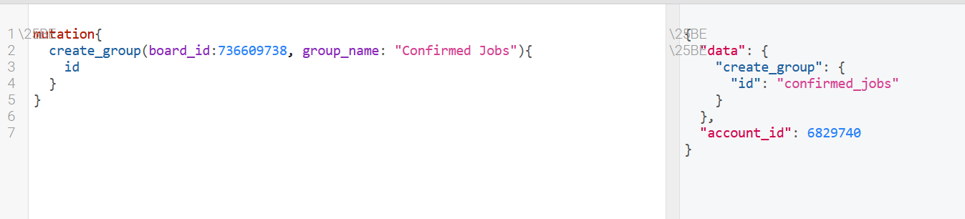

Step 3: Create columns

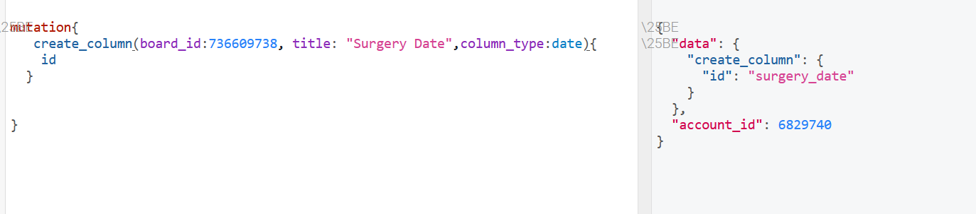



Note: Status & Dropdown box cannot add labels via API.

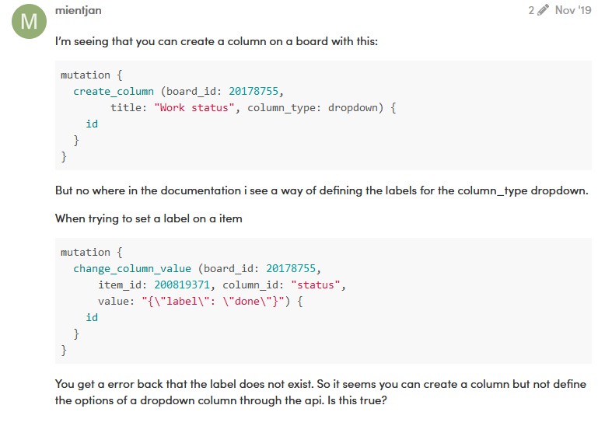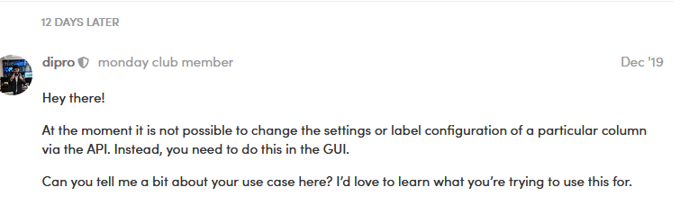

Step 4: Create item with column values

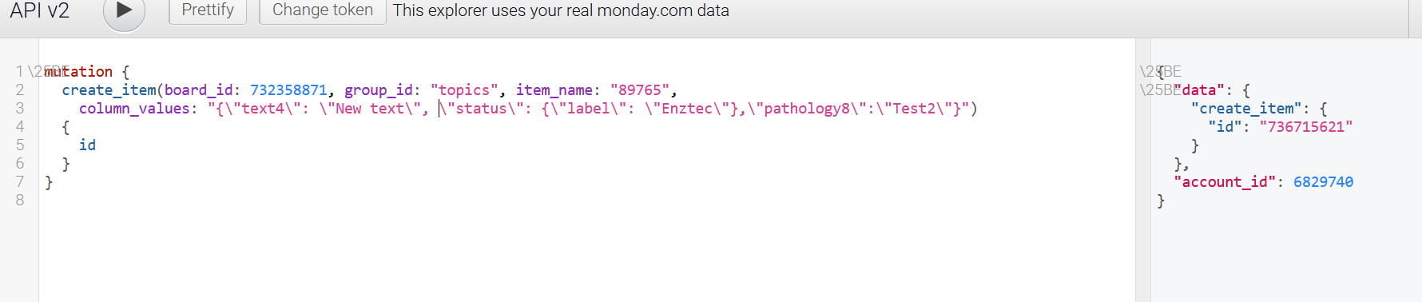

Note：Status labels: Case sensitivity

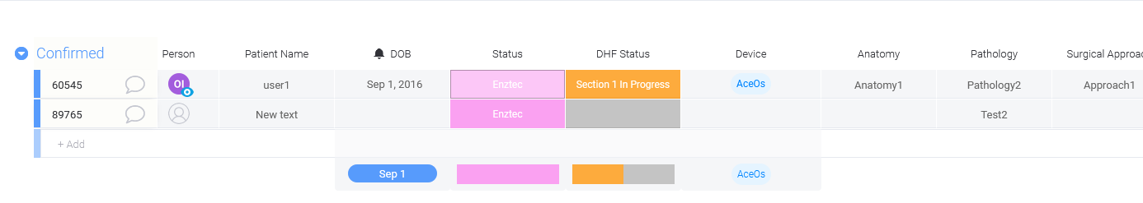

Step 5: Update Status column:

